Title of the publication for »Akademija strojništva 2024«
  - Name Surnameª, Name Surname^{b}, Name Surname^{b}, Name Surname^{a*}
ªUniversity of Ljubljana, Faculty of Mechanical Engineering, Aškerčeva 6, 1000 Ljubljana (* name.surname@fs.uni-lj.si)
^{b}University of Maribor, Faculty of Mechanical Engineering, Smetanova ulica 17, 2000 Maribor
Write abstract into this text box. Select the writing style “Abstract” (font Garamond, 10 pt, bold, justify). Abstract should not be longer than 150 words. Shortly describe the background/problem, methods and main conclusions. The size of this textbox is automatically adjusted to the size of the text.

Introduction
Short research paper for “Akademija strojništva 2022” needs to be prepared according to this template. Total length of the paper is 2 pages (4 columns in total) including title, main text and references as shown in this template.
Final paper should be submitted in MS WORD and PDF format to the prispevki@zveza-zsis.si. Please name the manuscript file as:
[Last name of first author]_Akademija_2024
e.g.: Zupančič_Akademija_2024
If the paper doesn’t meet the formatting requirement according to this template, you will be invited to resubmit the paper.

Materials and methods
Paper should include main sections (titles): Introduction, Content sections (Methods, Materials, Results, Discussion) and Conclusions. Title of main sections should be written with the style “Heading 1” (font Garamond, 12 pt, bold, left indent).
The content can also include subsections (i.e. titles on the second level). This is written as bolded text at the beginning of specific paragraph, finished by the comma. The rest of the text is continued in the same line with the writing style “Normal”. Example of the subsection (Equations) is shown in the next paragraph.
Equations. Insert equations by using MS Office Equation Editor or any other editor of your choice (e.g. MathType Equation Editor). Equations should be justified (we recommend using tabs as in example below) and numbered. Equation (1) is used to calculate the area of a circle
$A=πr^{2}$ (1)
where A is the area and r is circle radius.
Figures. Please insert only high-quality figures (500 dpi or more). The recommended width of a figure is 8.5 cm (single column) and the maximum allowed width is 17.5 cm (double column). In case you insert figure that is wider than a single column, make sure the entire text of the content is still within two columns. Every inserted figure should be cited in the main text. Make sure that axis labels and all other text within a figure is more or equal to 6 pt.
Tables. If possible, avoid vertical lines when inserting a table. Table 1 is showing the recommended formatting. The recommended width of a table is 8.5 cm (single column) and the maximum allowed width is 17.5 cm (double column). In case you insert table that is wider than a single column, make sure the entire text of the content is still within two columns. Every inserted table should be cited in the main text. Make sure that font size in a table is not less than 8 pt.
Citations and references. All references mentioned at the end of the paper should be cited in the main text, and vice versa. Citations are provided in a square bracket individually [1] or merged [1-3]. References should be added at the end of the manuscript without special title “References” as show in this template. For references use writing style “References” (font Garamond, 9 pt, left indent).
Example references for a journal paper [1,2], book [3], computer software [4] and web page [5] is shown at the end of this template.
Reference formatting for a journal paper is:
[no.] First Author. Abbreviated journal name volume (year) pages.
Reference formatting for a book is:
[no.] First Author. Book title, edition (year).

Results and discussion
Results and discussion can be given in a single or separated sections. For clarity, this template includes two figures, one table and some text in order to represent the maximum length of the paper.
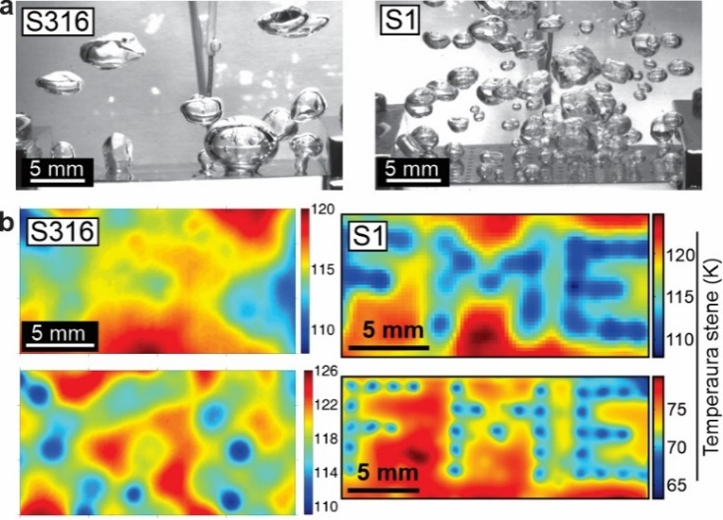
Figure 1: (a) Saturated nucleate boiling recorded with high-speed video camera and (b) transient temperature field recorded with high-speed thermographic camera. Boiling was investigated on bare stainless steel foil (S316) and laser textured foil (S1) at 100 kW/m². Figure (b) show the result or water (top) and FC-72 (bottom).
Nucleate boiling is one of the best heat transfer mechanisms taking place at low temperature differences between heated surface and surrounding fluid. This process can be enhanced by surface functionalization though wettability modifications and morphology changes on macro, micro and nano scale. As the boiling is widely utilized in different heat transfer applications, so are the working fluids different by their physical properties. This means that enhanced heat transfer surfaces would only be developed for a specific case. Previous research [2] has shown that laser texturing is able to produce surface microcavities in a wide size range (i.e. with diameters in the range of 0.2–10 μm), enabling effective bubble nucleation for completely different types of fluids on the same surface. Figure 1 is showing an example of nucleate pool boiling of water (high surface tension, polar fluid) and FC-72 (extremely ow surface tension, non-polar fluid) on a metal foil textured with pulsed fiber laser. Laser textured areas are created in a shape representing “FME” letters. Microcavities, formed on these areas, can clearly act as active nucleation sites for two completely different fluids (some key properties for both fluids are shown in Table 1).
New technology enables rapid and environmentally-friendly development of surfaces used in application of enhanced boiling heat transfer. Future research will hopefully enable development of new-generation heat transfer devices that will provide even higher heat transfer coefficients compared to the state-of-the art technology used today (see Fig. 2). It is important to note that surfaces are exposed to cyclic thermal loads in real applications, so the surface changes related to wettability transitions and general degradation should be carefully investigated in the future.
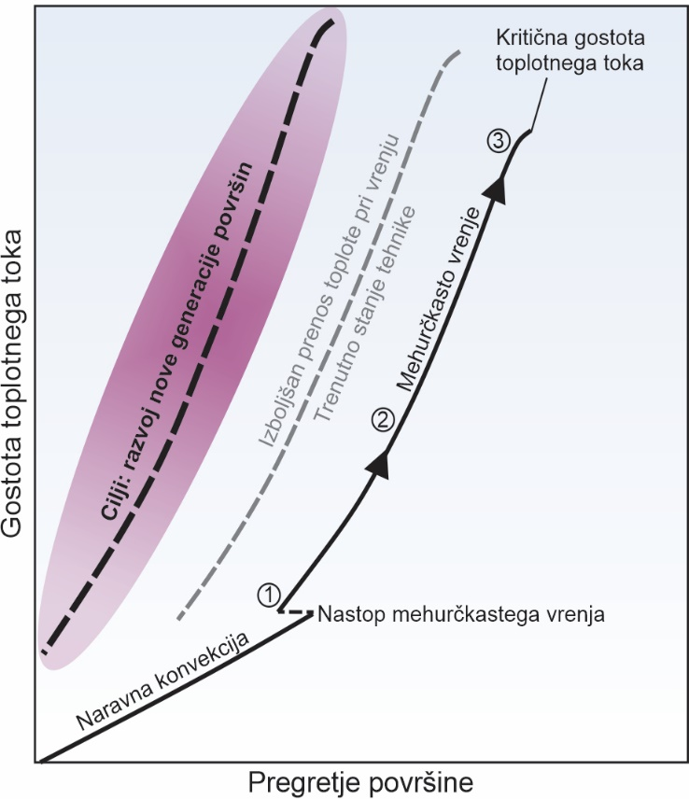
Figure 2: Main development goal is to shift the entire boiling cure towards lower superheat, as highlighted by the purple area.

Table 1: Saturation temperature (T_{sat}), latent heat of vaporization (h_{LV}), dynamic viscosity (η), density (ρ), specific heat (c_{p}), thermal conductivity (λ), surface tension (σ) and dielectric constant (ε) for water (H₂O) and FC-72 (C₆F₁₄). Properties are provided for 25°C and 1013 mbar.
fluid | water | FC-72 (perfluorohexane)
T_{sat} (°C) | 99.97 | 56
h_{LV} (kJ/kg) | 2257 | 88
η (mPas) | 0.89 | 0.64
ρ (kg/m³) | 997 | 1680
c_{p} (J/kgK) | 4182 | 1100
λ (W/mK) | 0.58 | 0,057
σ (mN/m) | 72 | 10
ε (/) | 78.5 | 1.75

Conclusions
Write here the concluding text. You can provide conclusions in a paragraph (or several paragraphs) or through bullet points as presented below:
- Important conclusion 1.
- Important conclusion 2.
- Important conclusion 3.
SUPPLEMENTARY INFORMATION. Supplementary information to support understanding the content can be submitted along with the main PDF file. Supplementary information can be provided in the form of a PDF, dataset can be given as XLS or XLSX files, videos can be provided in WMC, MPEG4 or AVI format. You can send several supporting files, but the size of individual file should not exceed 10 MB. There is no strictly defined template, however, the supporting PDF should have a front page with the title, authors and list of figures/tables included in the supporting information file. Please delete this section if you are not aiming to submit the supplementary information. Otherwise, please insert this text: Supplementary information is available at https://www.zveza-zsis.si/2024/12/10/akademija-strojnistva-2024-december-2024
ACKNOWLEDGEMENTS. This section is not obligatory. In general, authors acknowledge a funding source. In this case it is needed to write down the full name of funding organisation and a project number. In addition, you can acknowledge individuals or groups who somehow contributed to this work, but are not included in the list of authors.
[1] M. Zupančič et al. Appl. Therm. Eng. 91 (2015) 288-297.
[2] P. Gregorčič et al. Sci. Rep. 8 (2018) 7461.
[3] F.P. Incropera et al. Fundamentals of Heat and Mass Transfer, 6th. ed. (2006).
[4] E.W. Lemon et al. REFPROP, Ver. 9.11 (2014).
[5] GorenjeGroup. Robotizirano skladišče Navis, https://www.gorenjegroup.com/si/za-medije/medijske-knjiznice/video-vsebine (26.9.2020).

